**Inception Phase Mockups**

These diagrams represent a rough sketch of what HOOF pages and databases will look like under our design. We have designed pages representing the home page as well as areas we have designed as high-risk functions – donations and the database.

Diagram 1: This represents a view of the donation page for HOOF. It offers an option to enter information and send the use to iATS for payment processing, or to offer donations through PayPal or Amazon Smile.



Diagram 2: This represents the HOOF home page, continuing to feature the mission statement. It offers the options for donors to login to their accounts to repeat donations or update information, or for volunteers to sign in to theirs to update information to register available for events. It also features a quick link to donate now to facilitate user ease.

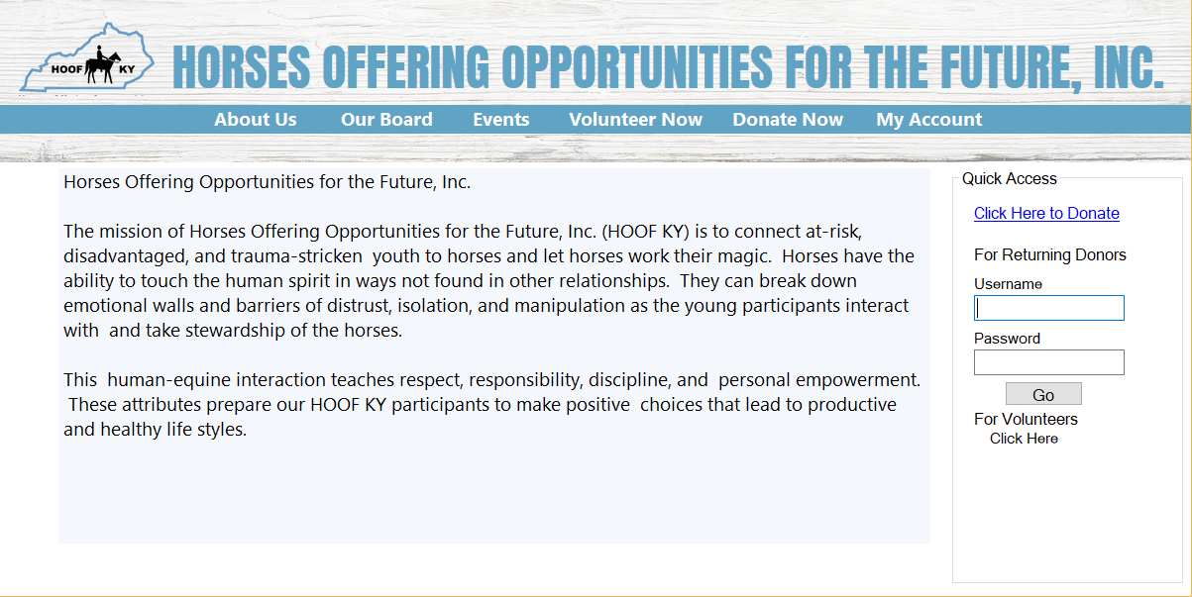

Diagram 3: This is a mockup of the MySQL database as it will be managed through the phpMyAdmin tool that integrates with WordPress. It offers a view of what a small volunteer table could look like, and gives a view of how other tables in the database will be accessed.

